**PAL (Performance Analyzer Tool)**

Performance is a function of how each of the component performs within a application which in PRPC includes the following:

1. **Browser**
2. **PEGARULES database server**
3. **Other systems accessed via connectors and services**
4. **Application Server: Where PRPC is running**
5. **Network: All the above components uses to communicate.**

See if you want to know about performance and Performance analysis in Pega you need to use a tool called PAL

How PAL is used in different roles

1. **QA Analysts :** Testing- run through a script, and take one reading at the end of the script process which goes through the PAL Advisor process to check performance efficiency
2. **System Administrators :** Troubleshooting production systems.

So there are different reasons why your system in Pega might be running slow some of them are

1. **Servers might be responding slow**
2. **Unoptimized DB Query properties etc…**
3. **Process Logic**
4. **Memory Management(Log Files are completely occupying space on server(Admin Teams)**
5. **Cache Management**
6. **UI designs(ex- loading of list of data in a screen without pagination, usage of inline styles)**
7. **Clipboard size for each transaction**
8. **Time taken to change from one screen to another screen**
9. **Using Deprecated Rules**

In Pega click on Configure > System > Peformance > PAL

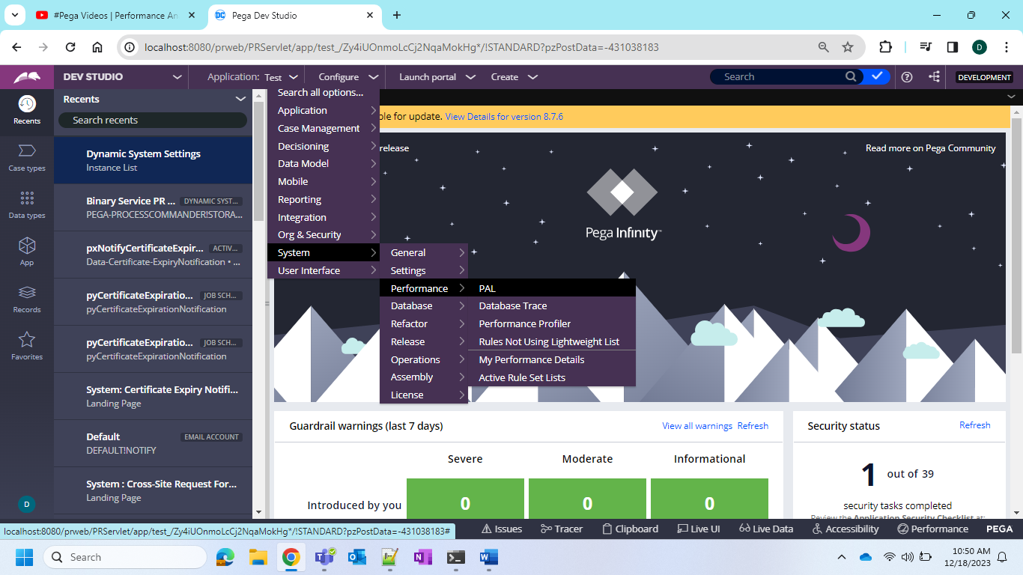

PRPC is also one application if you click on Launch Portal and launch user portal it will take some time to launch the portal. Let us say when it has loaded let us take clipboard size as 100 bytes with respect to only OOTB can be sometime moving from one screen to another screen

Now the size of the clipboard will be more than the size of the clipboard before launching the portal.

Let us take you have 10 screens it will take time from 1 screen to another screen let us take 3 seconds and from 2 nd to 3 rd it took 7 seconds and also it increases or decreases depending on the load. When time is too longer then it will have performance issue.

Now we need to identify our performance logs for every action.

1. **What is the size of the clipboard**
2. **What is the time it is taking from process to process, request to request or screen to screen database query time response time for these we need our analytical skills pega will not tell the value.**
3. **Ideal values are the initial execution values**
4. **Whatever you have implemented if it is same as the response time of the OOTB pega given time then whatever you did is perfect coding. But it is not possible actually**

We will have to add reading for every action that is initial reading and then one more reading and we have to compare all these values downloading into an excel and we have to do the comparison by ourselves. For this pega provides a tool called PAL.

So when I initially opened PAL the readings are as follows

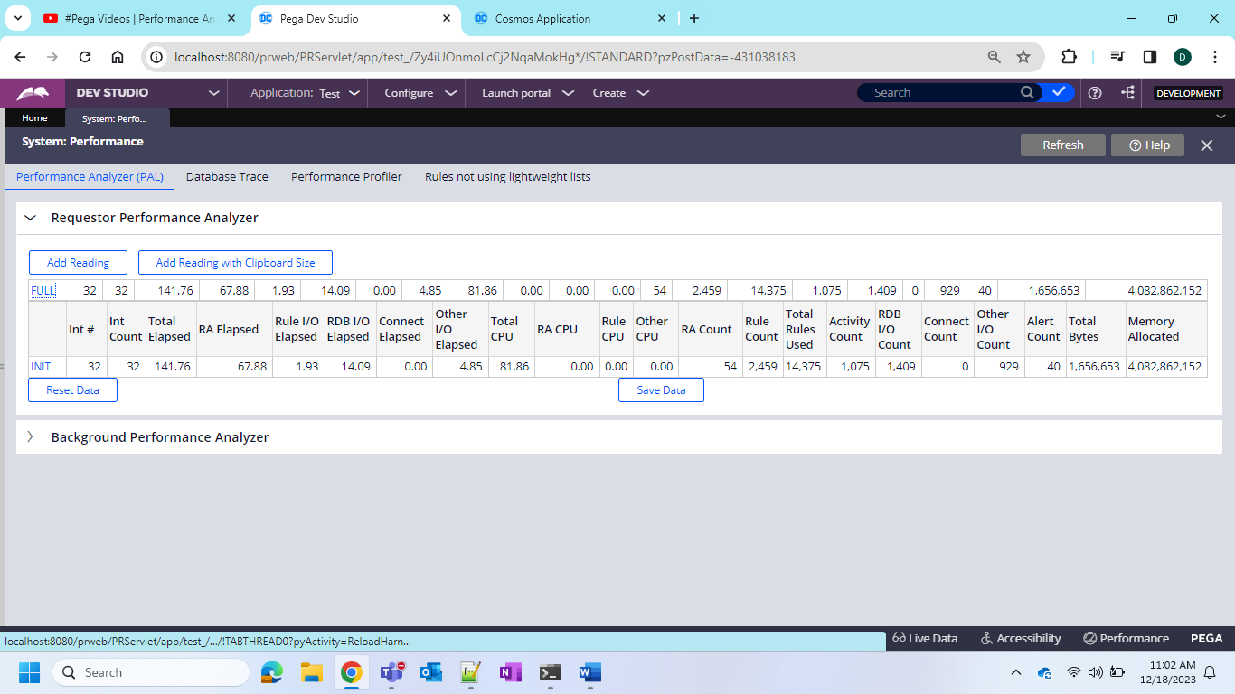

We see INIT initial count now I will do one thing I will add readings with Clipboard size here

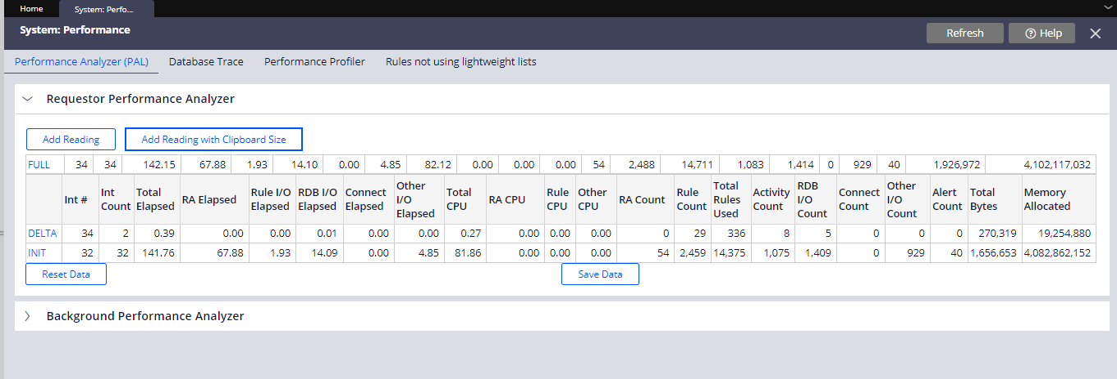

INIT reading we call it as initial reading and DELTA we call it as DELTA readings for the actions which you have performed

Now again lets open and compare now after freshly opening these are the readings

And now let me run one flow and once it opens one action is completed

Now click on add reading with clipboard size

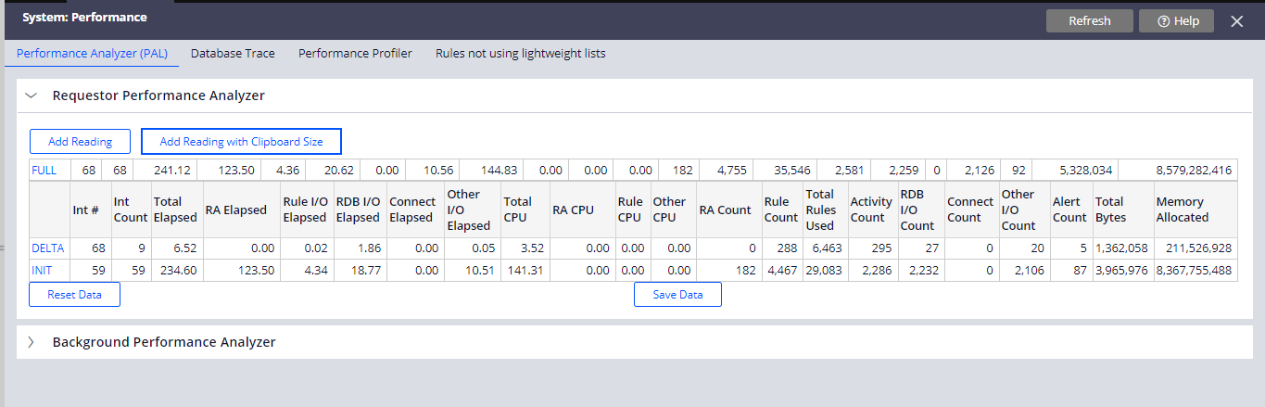

Now here if you see Int# where initial is 59 and DELTA is 68 which if you minus then it is 9 which is nothing but the interaction count which is shown on the 2 nd column and now let us do another screen and I am doing submit

Now let us do the add reading with clipboard size

Now the interaction count is 11 for launch it is 9 and from 1st to 2nd screen it is 11. Does it have drastic change? NO if the count is 9 and 100 between 2 screen then there is some issue means unnecessary interactions are happening not the pega OOTB your custom code also so you need to optimize your coding

So also we can see the bytes of memory used by clipboard

Initially it has taken some 83 and then 2.1 and then 2.4. so there is no much increase of size if the size is drastically increasing then you have to think about only that step or screen. When performing action am I not removing the pages properly in such way we can check.

Now you click on any one of the delta reading

And you can see the elapsed time and the CPU time and now the important thing is run execution counts and request summary

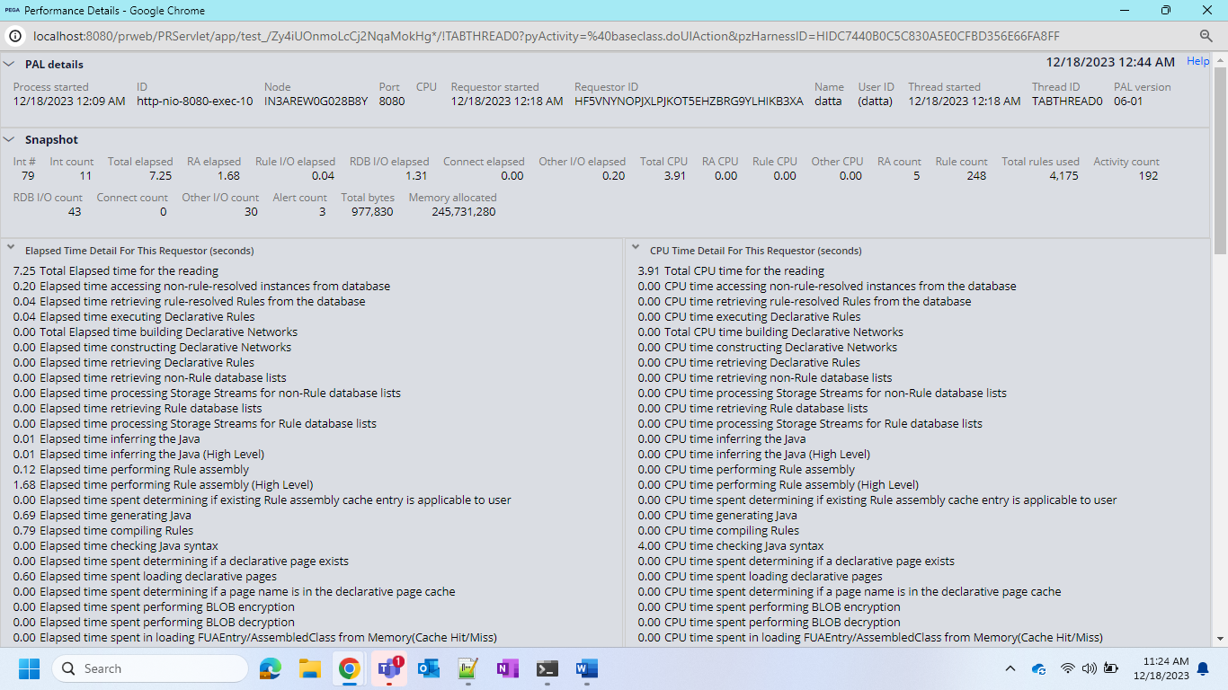

The time of the requestor when it has started and the PAL reading time when it has started and no of server interactions happening and no of bytes that are received by the server. You can check for multiple delta reading and you can see too much increase of bytes means you are sending lots of data to the server which might not be required. Might be large data and all.

You have to compare the init readings with delta readings and delta readings with the previous readings

Now if you want to export to excel click on Save Data and it will be exported to excel